**Code Repository Best Practices and Branching Strategy**

**Git Branching Strategy Guide**To enhance our GitHub management, I recommend adopting the GitLab Flow approach for our branching strategy. This guide outlines the core principles and use cases for each method within this strategy.  
Introduction:  
In the dynamic environment of software development, efficient collaboration, and streamlined release processes are crucial. GitLab Flow offers a robust solution designed for teams managing complex release cycles. By adopting GitLab Flow, we aim to simplify our development workflow, reduce overhead, and ensure seamless deployment processes.

**Why GitLab Flow?**GitLab Flow is designed to support teams with intricate release cycles, providing a straightforward, transparent, and efficient way to manage code. This approach allows developers to collaborate effectively and maintain multiple versions of code across different environments. Key benefits of GitLab Flow include: **1. Simplified Release Management:  
  -** Reduces the complexity associated with releasing, tagging, and merging code.  
  - Provides an easier way to deploy code by ensuring that commits flow downstream and are tested in all environments. **2. Enhanced Collaboration:  
  -** Facilitates collaboration among team members, making it suitable for teams of any size.  
  - Adaptable to various needs and challenges, ensuring flexibility in the development process. **3. Separation of Concerns:** - Emphasizes a clear separation between development (develop branch) and production code (main branch).  
  - Promotes the use of feature branches created from the develop branch and merged back after review.

**Core Principles and Use Cases:  
1. Feature Branches:**  - Developers create feature branches from the develop branch for new features or bug fixes.  
  - These branches are short-lived and merged back into the develop branch after a thorough review. **2. Release Branches:  
  -** For each release, a branch is created from the develop branch.  
  - This branch is tagged and thoroughly tested before being merged into the main branch for deployment. **3. Main Branch:**  - The main branch contains production-ready code.  
  - All changes flow downstream from the develop branch to the main branch, ensuring stability and consistency.  
By implementing GitLab Flow, we can enhance our development workflow, improve code quality, and ensure efficient deployment processes. This strategy will enable us to manage complex release cycles with greater ease, making our development efforts more productive and streamlined.

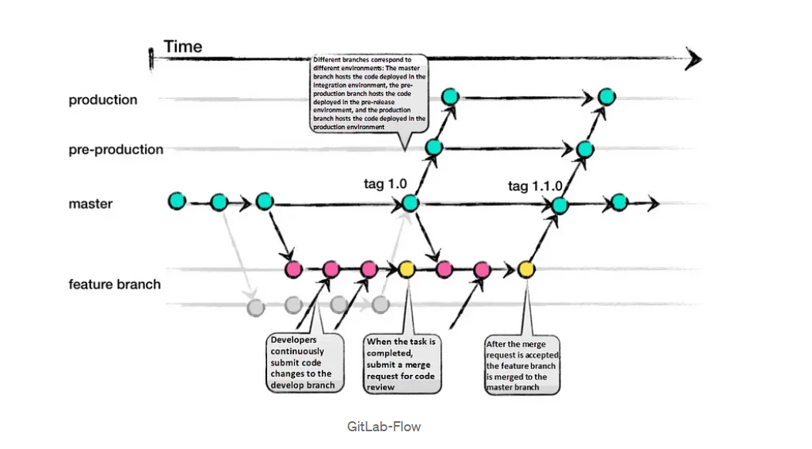

**Best Practices and Implementation for using GitLab Flow**1. **Use of Feature Branches:**  
  - Always create a feature branch for any new development instead of committing directly to the main branch.  
  - This keeps the main branch clean and allows for easy code reviews before merging.

2. **Test All Commits:**  
  -The CI must be configured to run tests on all commits, not just those on the main branch.  
  - This ensures the main branch remains stable and reduces the need to test it before starting new development.

3. **Start and Target Main:**  
  - Begin development from the main branch and target it for merges.  
  - This practice keeps branches short-lived and ensures thorough reviews before merging.

4. **Run Tests in Parallel:**  
  - Run tests immediately on new commits in feature branches.  
  - Use parallel testing to speed up the process and ensure a complete test suite runs on each commit.  
  
5. **Perform Code Reviews Before Merging:**  
  - Conduct code reviews promptly to catch issues early in the development cycle.  
  - This helps in identifying and resolving problems sooner, making the development process smoother.

6**. Fix Bugs in Main First:**  
  - Always fix bugs in the main branch first before addressing them in release branches.  
  - This ensures the main branch is up-to-date and prevents missing fixes in future releases.  
  
7. **Write Descriptive Commit Messages:**  
  - Commit messages should clearly state what was done and why.  
  - This aids in code reviews and helps future contributors understand the development process.  
  
8. **Automate Deployments Based on Branches or Tags except for production:**  
  - Use automation to deploy based on specific branches or tags, reducing manual intervention.  
  - A production branch must be created to trigger deployments instead of always using the main branch.

9. **Set Tags Manually and base releases on tags:**  
  - Developers should manually set tags to trigger CI actions, ensuring control over the repository.  
  - Use tags to track detailed metrics and generate reports for new versions.  
  
10. **Base Releases on Tags:**   
   - Create new releases for each tag to maintain a clean and efficient development environment.  
   - This practice ensures consistency and clarity in versioning and deployment.

**Conclusion**

By adopting GitLab Flow as our branching strategy, we can handle complex release cycles more efficiently and clearly. This will enable us to have a structured use of feature branches, release branches, and the separation of development and production code enhances collaboration, reduces overhead, and ensures more reliable deployments. This approach guarantees that every commit is thoroughly tested in all environments, boosting our code quality and stability. Embracing this strategy will streamline our development process, making our workflows more productive and adaptable to various needs. With this document, we are well-prepared to implement GitLab Flow effectively, leading to a more organized and efficient software development lifecycle.